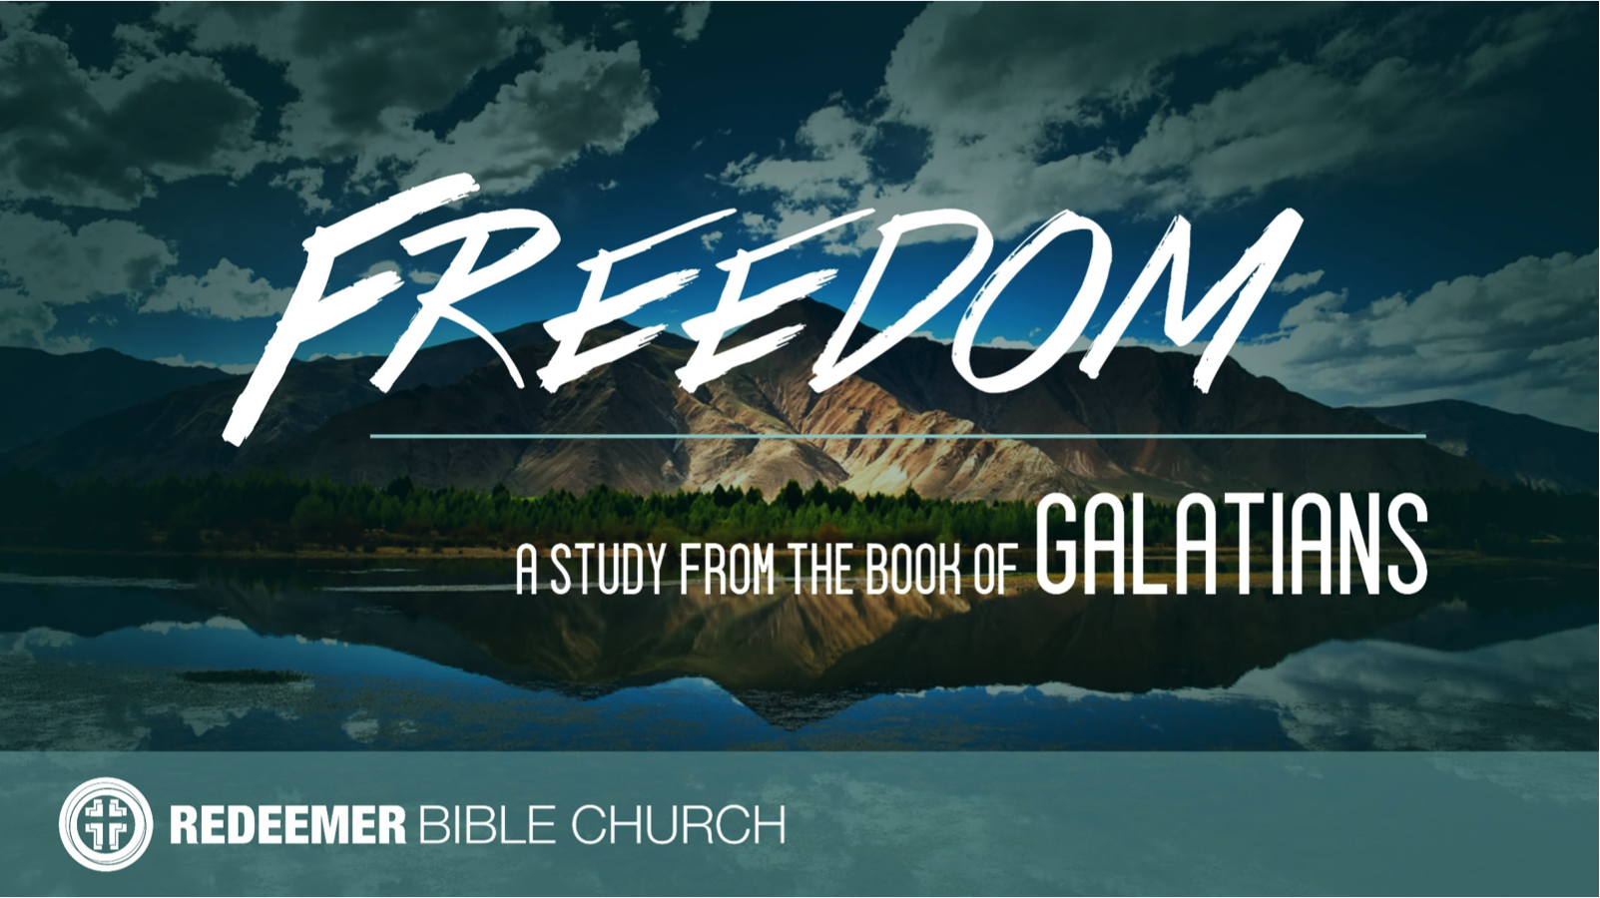
The Book of Galatians
Redeemer Bible Church
Speaker: Jon Benzinger
September 10, 2017
Escaping Gospel Treason, Pt 2 (Galatians 1:8-10)
Galatians is a letter Paul wrote c. 48-49 AD – Readers: Christians in “Galatia” = Modern Turkey (see Acts 13-14) – Point: Defend the Gospel of Faith in Jesus Alone for Salvation

I. The Gospel ________________________________________
(1:8a, 9a; 1 Tim 4:1, 2 Jn 7-11, 1 Kgs 13:1-24a)

II. The Gospel ________________________________________
(1:8b, 9b; 2 Pet 2:1, 17, Rev 2:16, Gal 1:8-9, 2:26, 21, 3:10-14, 26, 5:1)

III. The Gospel _______________________________________
(1:10; Jn 5:18, Gal 4:16, 1 Cor 4:3-4, 1 Thes 2:3-4, 2 Cor 5:9-11, Ezek 3:4-10, 33:1-9, Acts 20:25-26)

Our goal every Sunday is that you go home (1) understanding the passage better, (2) having some ideas about how to live the passage & (3) standing in awe of Jesus.
Growth Questions
These questions are meant to help you apply Sunday’s message to your life personally and to help others – like the people in a Growth Group – do the same. Can being honest and vulnerable about your life be intimidating? Is it OK to struggle and have real questions? The answer to both questions is “Yes.” So, a Growth Group is meant to be a safe place where we help anyone know, love and serve Jesus better. If you’re not in one, you can sign up online and then just show up. If you missed this or any message, you can go to our website, iTunes or our youTube page.

- Explain why passages like Galatians 1:8-9 are so offensive to modern ears.

- Explain how the way we think people are going to respond to us effects if and how we share the Gospel with them.

- What are the most influential excuses you give yourself for not sharing Christ with the people you love that need Him?

- Read 2 Corinthians 5:9-11. How does this passage impact the thought of talking about Jesus with someone you love that needs Him?

Recommended Reading

Chandler, The Explicit Gospel
Gilbert, What is the Gospel?
Greer, Gospel
Lutzer, Rescuing the Gospel
Ortland, The Gospel*
Thomas, How the Gospel Brings Us All The Way Home

* = Start here

- Write out a prayer based on your answers above.

If you need help for any reason, go to https://redeemeraz.org/counseling

