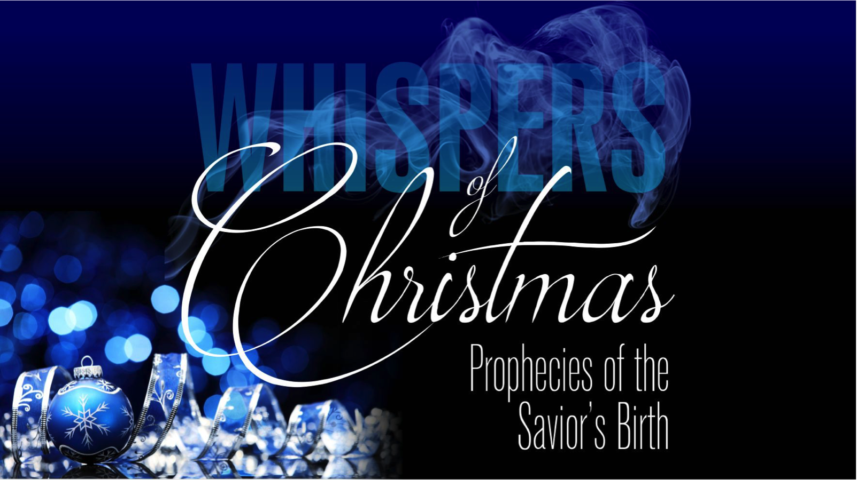
Whispers of Christmas
Redeemer Bible Church
Speaker: Jon Benzinger
December 4, 2016
Locating Where The Messiah Would Be Born (Micah 5:2)
Our Mission: To help people know, love & serve Jesus

1. Understand ________________________________________

2. Admit _____________________________________________

Our goal every Sunday is that you go home (1) understanding the passage better, (2) having some ideas about how to live the passage & (3) standing in awe of Jesus.
Growth Questions
These questions are meant to help you apply Sunday’s message to your life personally and to help others – like the people in a Growth Group – do the same. Can being honest and vulnerable about your life be intimidating? Is it OK to struggle and have real questions? The answer to both questions is “Yes.” So, a Growth Group is meant to be a safe place where we help anyone know, love and serve Jesus better. If you’re not in one, you can sign up online and then just show up. If you missed this or any message, you can go to our website, iTunes or our youTube page.

- Describe the thought and emotions that go into waiting for something, maybe by explaining something you really wanted, but had to wait for.

- Read Micah 5:2-6a. Write as many observations as you can about what the “ruler” will be and do.

- Prophecy shows a plan. Respond to the idea that God planned your salvation 1000s of years before you were born.

- The last line in Micah 5:2 shows it was God who was born in Bethlehem. Explain what it means to you that God the Son left heaven, entered time and became one of us to live and die in our place to save us.

- Write out a prayer based on the growth questions you answered above.
Recommended Reading

E.W. Hengstenberg, Christology of the Old Testament
Walter Kaiser, The Messiah in the Old Testament
John MacArthur, God in the Manger

If you need help for any reason, go here https://redeemeraz.org/counseling

