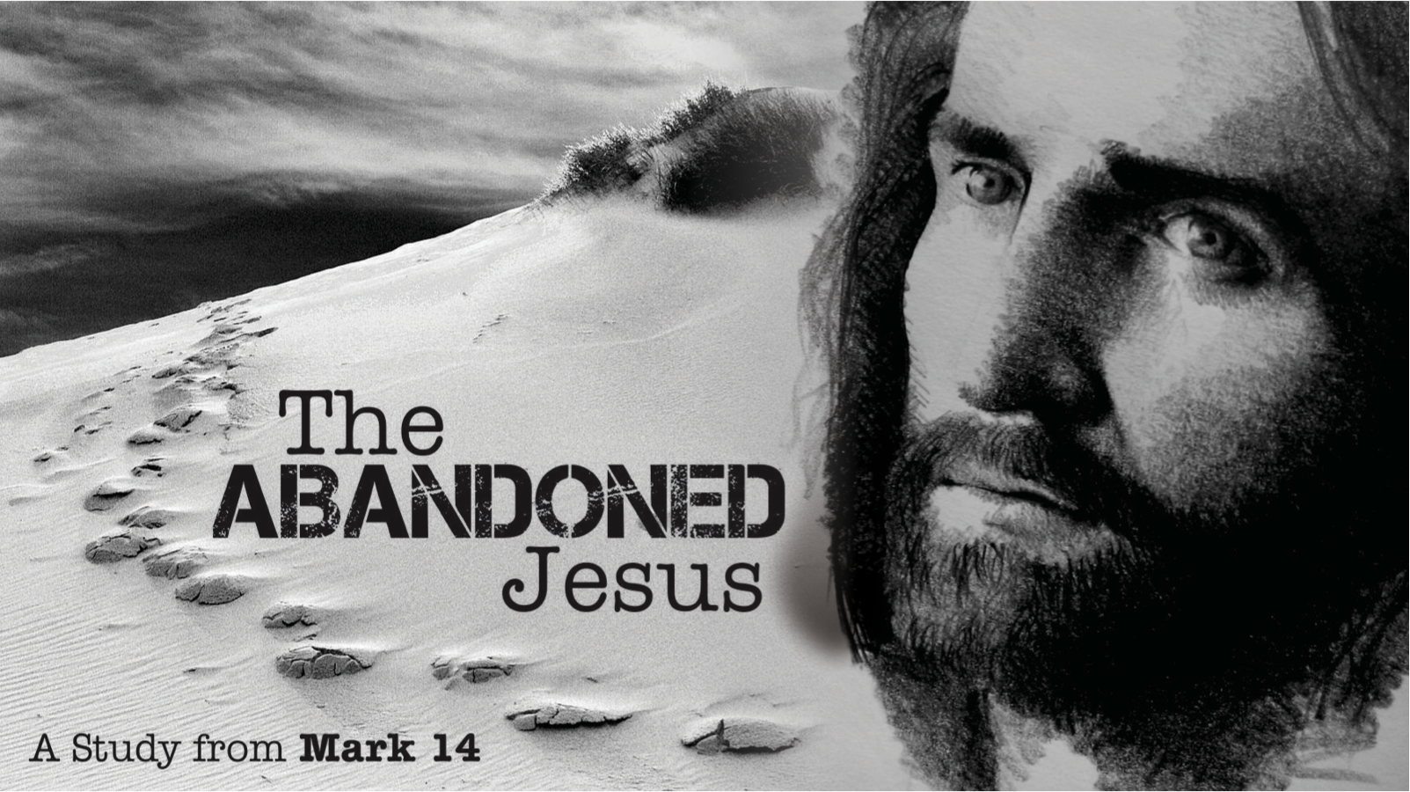
The Abandoned Jesus, Pt. 1
Redeemer Bible Church
Speaker: Jon Benzinger
January 1, 2017
Having a Beautiful Commitment to Jesus (Mark 14:1-11)
Our Mission: To help people know, love & serve Jesus
Jesus’ Last Days | Saturday | Sunday | Monday | Tuesday | Wednesday | Thursday | Friday | Sunday

1. Struggle to _________________________________________
(Mark 14:1-2, 10-11; Matt 26:1-5, 14-16, Rom 8:12-13, Gal 5:16-26)

2. Struggle to _________________________________________
(Mark 14:3-9; Matt 26:6-13, John 12:2-11, Luke 10:38-42, Ezek 36:27)

Our goal every Sunday is that you go home (1) understanding the passage better, (2) having some ideas about how to live the passage & (3) standing in awe of Jesus.
Growth Questions
These questions are meant to help you apply Sunday’s message to your life personally and to help others – like the people in a Growth Group – do the same. Can being honest and vulnerable about your life be intimidating? Is it OK to struggle and have real questions? The answer to both questions is “Yes.” So, a Growth Group is meant to be a safe place where we help anyone know, love and serve Jesus better. If you’re not in one, you can sign up online and then just show up. If you missed this or any message, you can go to our website, iTunes or our youTube page.

- Is there anything recently you committed to that you either backed out on / just gave up on?

- Do you know a Judas, someone who seemed to have a commitment to Christ, but something else came along that captured his/her heart more so they abandoned Him?

- Read Galatians 5:16-26. What does this passage say about our inner Judas (“the flesh”) and how God has provided for us to combat it?

- After listening to the message, what “beautiful” thing (or things) is God encouraging you to do?

- Write out a prayer based on the growth questions you answered above.

Recommended Reading

J.C. Ryle, Holiness
__________, Practical Religion
A.W. Tozer, The Pursuit of God

If you need help for any reason, go here https://redeemeraz.org/counseling

