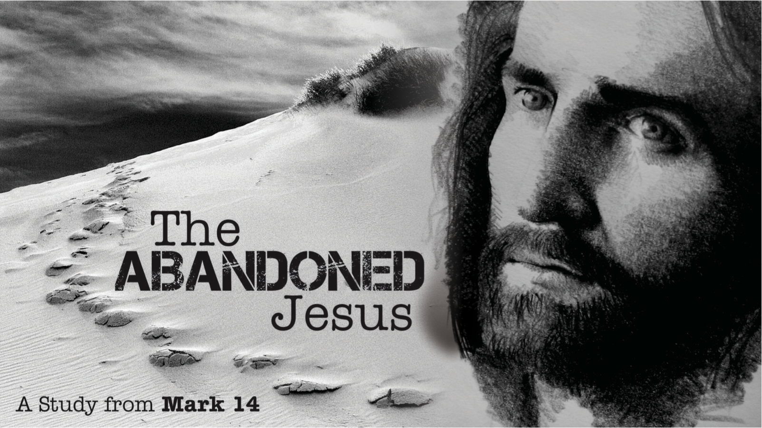
The Abandoned Jesus, Pt. 3
Redeemer Bible Church
Speaker: Jon Benzinger
January 15, 2017
Loving The One Who Chose To Save Us (Mark 14:32-42)
Our Mission: To help people know, love & serve Jesus
Jesus’ Last Days | Saturday | Sunday | Monday | Tuesday | Wednesday | Thursday | Friday | Sunday
Point: Though tormented by temptation, Jesus __________ to be your Savior
(Mark 14:32-26; Lk 22:53; )
1. Replaced _________________________
(Mark 14:12-16; Luke 22:20, Heb 8:6-13, 10:11-18)

2. Restricted _________________________
(Mark 14:17-21; Acts 2:23, John 17:12, 1 Cor 11:27-31, 10:16)
3. Remembers _________________________
(Mark 14:22-24; Luke 22:1, 1 Cor 11:25-26)
=
1. Learn Gethsemane’s Lessons _________________________
(Mark 14:32-36; Titus 2:12; Heb 12:4, Gal 5:24, Rom 8:13, 1 Tim 4:7, Acts 24:16)
1. Detest ___________________

2. Desire ___________________

3. Determine _________________

2. Learn Gethsemane’s Lessons _________________________
(Mk 14:33, Mt 26:38, Gal 6:2; Heb 5:7; Mk 14:35-36; Ro 8:15, Gal 4:6, Jn 17:23; Mk 14:36; Mk 14:38, Mt 6:13; Mk 15:35, 39-40, Lk 11:8, 18:1)
1. Pray ________________________ 5. Pray ________________________

2. Pray ____________________ 6. Pray _______________________

3. Pray _________________________ 7. Pray ________________________

4. Pray ______________________

Our goal every Sunday is that you go home (1) understanding the passage better, (2) having some ideas about how to live the passage & (3) standing in awe of Jesus.
Growth Questions
These questions are meant to help you apply Sunday’s message to your life personally and to help others – like the people in a Growth Group – do the same. Can being honest and vulnerable about your life be intimidating? Is it OK to struggle and have real questions? The answer to both questions is “Yes.” So, a Growth Group is meant to be a safe place where we help anyone know, love and serve Jesus better. If you’re not in one, you can sign up online and then just show up. If you missed this or any message, you can go to our website, iTunes or our youTube page.

- What stood out to you about Jesus’ temptations in Gethsemane and why?

- What stood out to you about sin from this event in Gethsemane? Please explain.

- What one lesson about prayer could you take from Gethsemane and apply to your life that’d be most impactful?

- Read Romans 8:15 and Galatians 4:6. How can the truths here impact your prayers?

- Write out a prayer based on the growth questions you answered above.

If you need help for any reason, go here https://redeemeraz.org/counseling

