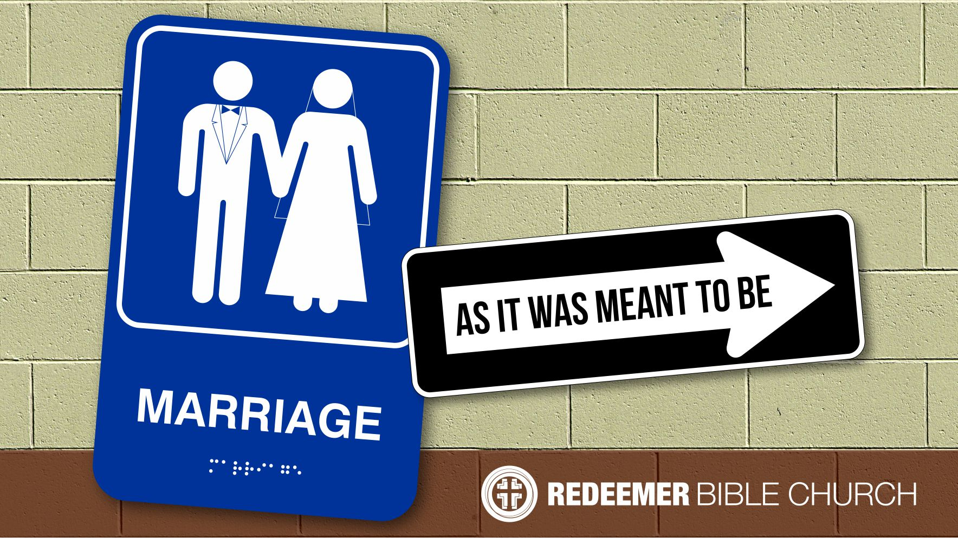
Marriage, Pt. 1
Redeemer Bible Church
Speaker: Jon Benzinger
April 30, 2017
What It Means To Be Male & Female (Genesis 1-3)
Our Mission: To help people know, love & serve Jesus

I. Men & Women Are __________________________________
(Genesis 1:26-28; Gen 9:4-6, James 3:9)

II. Men & Women Have ________________________________
(Genesis 1:27; Gen 2:7-23, 3:6-11, 3:16-17; Col 3:18-19)

- God _______________________________________
(Gen 1:27, 5:2)

- God _______________________________________
(Gen 2:7, 18-23; 1 Tim 2:12-13)

- God _______________________________________
(Gen 2:21; 1 Cor 11:8)

- God _______________________________________
(Gen 1:5-10, 2:19-20, 23, 3:20)

- God _______________________________________
(Gen 2:18, 23)

- God _______________________________________
(Gen 3:6-11, 17)

- God _______________________________________
(Gen 3:16, 4:7, Col 3:18-19)

Our goal every Sunday is that you go home (1) understanding the passage better, (2) having some ideas about how to live the passage & (3) standing in awe of Jesus.

Growth Questions
These questions are meant to help you apply Sunday’s message to your life personally and to help others – like the people in a Growth Group – do the same. Can being honest and vulnerable about your life be intimidating? Is it OK to struggle and have real questions? The answer to both questions is “Yes.” So, a Growth Group is meant to be a safe place where we help anyone know, love and serve Jesus better. If you’re not in one, you can sign up online and then just show up. If you missed this or any message, you can go to our website, iTunes or our youTube page.

- How does a person know if he or she has a good marriage? Please explain.

- Explain whether or not your answer to the above question is biblical and why.

- In your own words, explain what life should look like with both men & women being made in the image of God. In other words, how should that impact a marriage relationship?

- Why is it important to see that Jesus is the perfect picture both equality and submission in the Trinity?

Recommended Reading

Bryan & Kathy Chapell, Each for the Other
Wayne Mack, Your Family God’s Way
Gary & Betty Ricucci, Love That Lasts
RC Sproul, The Intimate Marriage
Alexander Strauch, Equal Yet Different.
Paul Tripp, What Did You Expect?

- Write out a prayer based on the growth questions you answered above.

If you need help for any reason, go to www.redeemeraz.org/counseling

