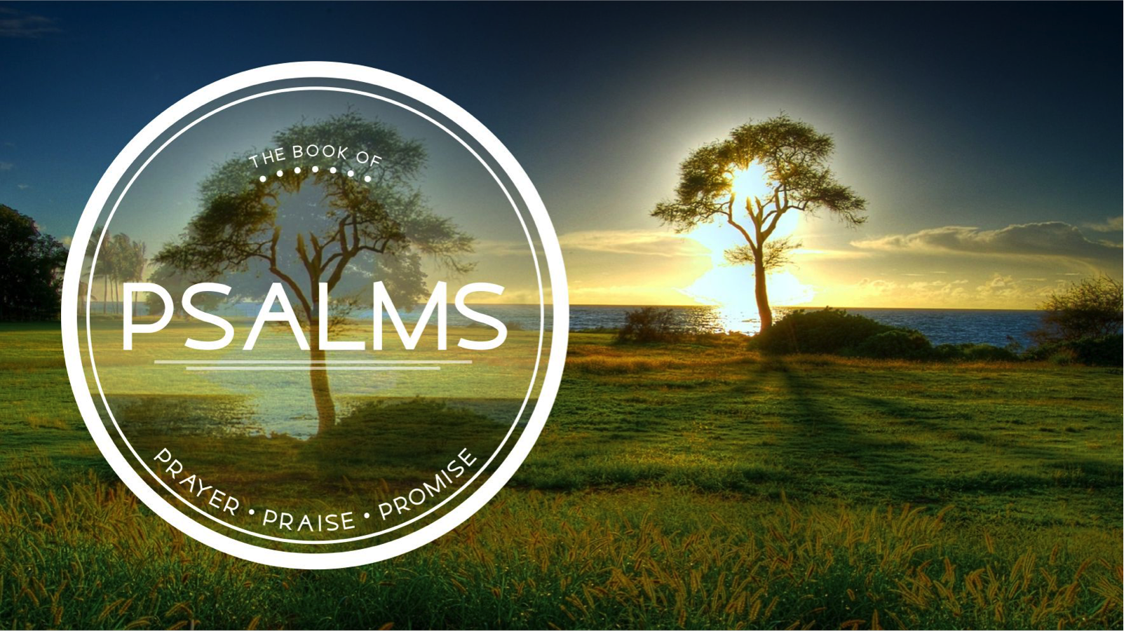
The Book of Psalms
Redeemer Bible Church
Speaker: Jon Benzinger
November 6, 2016
How To Deal With Pain & Suffering (Psalm 3:1-8)
Our Mission: To help people know, love & serve Jesus

1. Tell _______________________________________________
(Psalm 3:1-2)

2. Tell _______________________________________________
(Psalm 3:3-4)

3. Rest _______________________________________________
(Psalm 3:5-6)

4. Talk ______________________________________________
(Psalm 3:7-8)

Our goal every Sunday is that you go home (1) understanding the passage better, (2) having some ideas about how to live the passage & (3) standing in awe of Jesus.
Growth Questions
These questions are meant to help you apply Sunday’s message to your life personally and to help others – like the people in a Growth Group – do the same. Can being honest and vulnerable about your life be intimidating? Is it OK to struggle and have real questions? The answer to both questions is “Yes.” So, a Growth Group is meant to be a safe place where we help anyone know, love and serve Jesus better. If you’re not in one, you can sign up online and then just show up. If you missed this or any message, you can go to our website, iTunes or our youTube page.

- Describe a time when the trouble was really intense and God answered your prayers.

- Read Psalm 3:1-2. Are you honest with God in prayer? Please explain why or why not.

- Read 3:3-4. Explain how telling your pain about your God helps with your pain.

- How can the life, death and resurrection of Jesus give us the perspective we need in our pain?

- Write out a prayer based on the growth questions you answered above.

If you need help for any reason, go here https://redeemeraz.org/counseling

