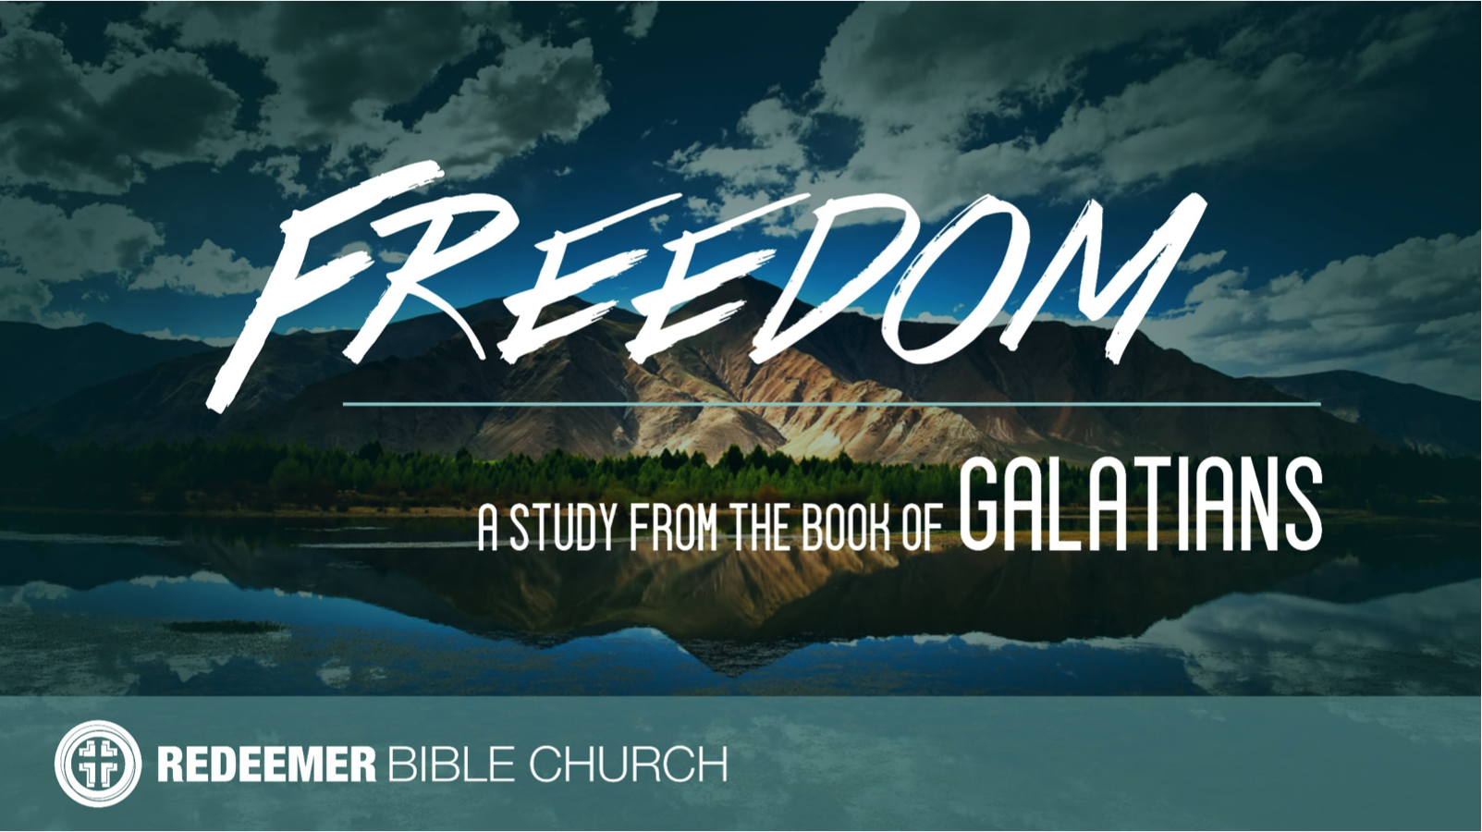
The Book of Galatians
Redeemer Bible Church
Speaker: Jon Benzinger
August 20, 2017
Why You Should Listen Closely To Galatians (Gal 1:1-2)
Our Mission: To help people know, love & serve Jesus

I. Paul’s __________________________________
(1:1; Gal 1:13-14, Phil 3:6, 2 Cor 5:10, 1 Cor 10:31, Phil 1:21)

II. Paul’s __________________________________
(1:1; 2 Cor 12:12, 1 Cor 15:9, Eph 2:20, Matt 28:18, )

III. Paul’s __________________________________
(1:2; 2 Pet 3:15)

Our goal every Sunday is that you go home (1) understanding the passage better, (2) having some ideas about how to live the passage & (3) standing in awe of Jesus.
Growth Questions
These questions are meant to help you apply Sunday’s message to your life personally and to help others – like the people in a Growth Group – do the same. Can being honest and vulnerable about your life be intimidating? Is it OK to struggle and have real questions? The answer to both questions is “Yes.” So, a Growth Group is meant to be a safe place where we help anyone know, love and serve Jesus better. If you’re not in one, you can sign up online and then just show up. If you missed this or any message, you can go to our website, iTunes or our youTube page.

- Read Philippians 1:21. What do you think this means and what would it look like in your life specifically if this described your life too?

- In your own words, explain why people running around today calling themselves apostles are spiritually dangerous?

- Explain why it’s critical to connect the office of a capital A Apostle with their message.

- In your opinion, what would be different about the church in general if Christians refused to be lone rangers?

Recommended Reading

Bainton, Here I Stand
Lawson, The Historic Boldness of Martin Luther
Luther, Table Talk
Reeves, The Unquenchable Flame
Schreiner, Faith Alone
Sproul, The Legacy of Luther
_____, Faith Alone
Sunshine, The Reformation for Armchair Theologians

- Write out a prayer based on the growth questions you answered above.

If you need help for any reason, go here https://redeemeraz.org/counseling

