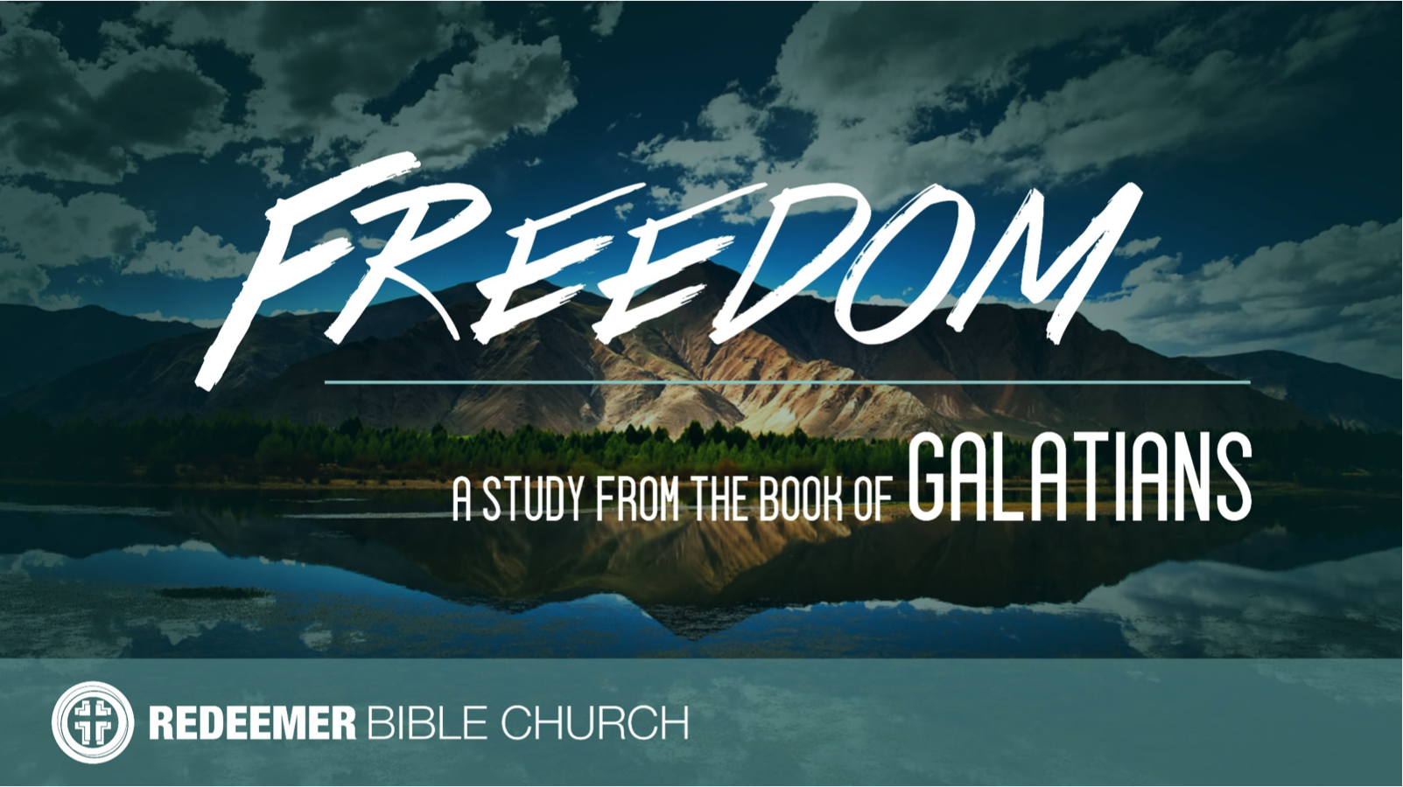
The Book of Galatians
Redeemer Bible Church
Speaker: Jon Benzinger
September 3, 2017
Escaping Gospel Treason (Galatians 1:6-7)
Galatians is a letter Paul wrote c. 48-49 AD – Readers: Christians in “Galatia” = Modern Turkey (see Acts 13-14) – Point: Defend the Gospel of Faith in Jesus Alone for Salvation

I. Devalue ___________________________________________
(1:6; Mk 6:6, Heb 5:11-12)

II. Recognize _________________________________________
(1:6-7; Exod 32:8, Gal 4:9-10, 5:4, Heb 11:6, 1 Jn 5:1)

III. Assume __________________________________________
(1:7; Acts 17:11, 2 Cor 11:3-4, 13-15, 1 Jn 4:6)

Our goal every Sunday is that you go home (1) understanding the passage better, (2) having some ideas about how to live the passage & (3) standing in awe of Jesus.
Growth Questions
These questions are meant to help you apply Sunday’s message to your life personally and to help others – like the people in a Growth Group – do the same. Can being honest and vulnerable about your life be intimidating? Is it OK to struggle and have real questions? The answer to both questions is “Yes.” So, a Growth Group is meant to be a safe place where we help anyone know, love and serve Jesus better. If you’re not in one, you can sign up online and then just show up. If you missed this or any message, you can go to our website, iTunes or our youTube page.

- Explain why you think we often care so much about the trivial and so little about the eternal, especially the eternal destinies of the lost people all around us.

- Read Romans 9:1-3. Compare Paul’s words to the regular Christians thoughts towards the lost.

- Who is the functional God (vs. one’s professed God) of a person who’s core motivation is trying to be right with God based on good works and how does that play itself out in their lives?

- What reasons can you give for how good it actually is to assume every religious teachers is a heretic until proven otherwise?

Recommended Reading

Chandler, The Explicit Gospel
Gilbert, What is the Gospel?
Greer, Gospel
Lutzer, Rescuing the Gospel
Ortland, The Gospel*
Thomas, How the Gospel Brings Us All The Way Home

* = Start here

- Write out a prayer based on your answers above.

If you need help for any reason, go to https://redeemeraz.org/counseling

