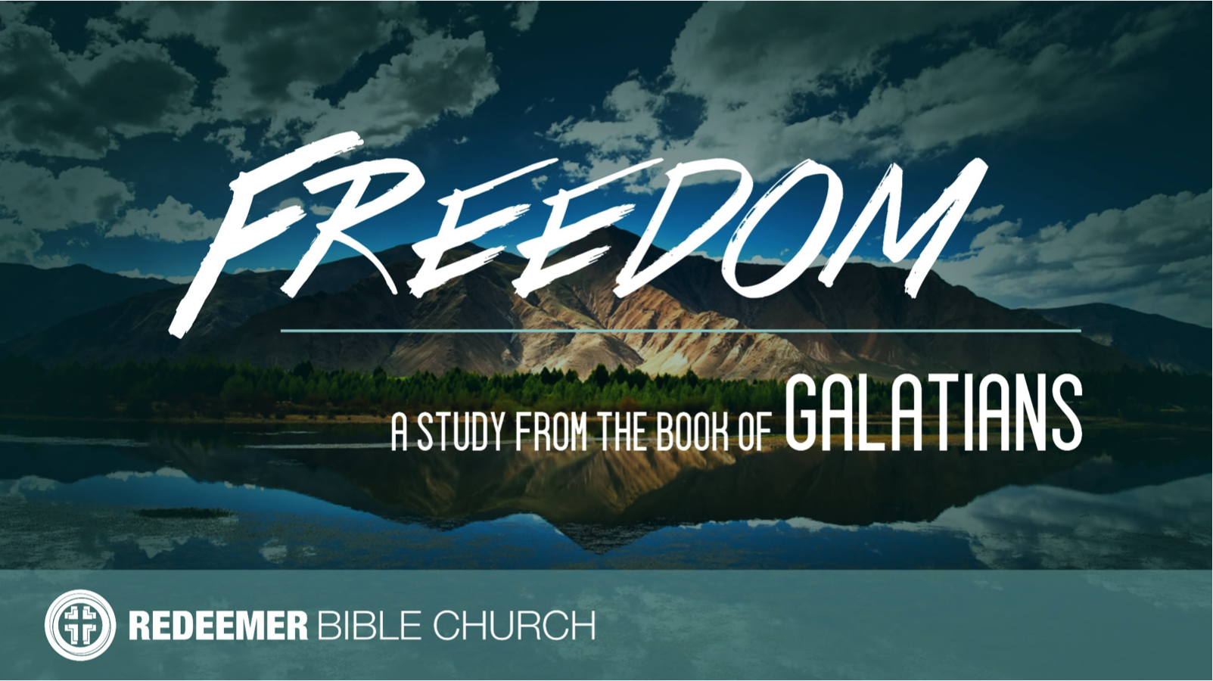
The Book of Galatians
Redeemer Bible Church
Speaker: Jon Benzinger
October 8, 2017
Christianity is Supernatural, Part 3 (Galatians 2:1-10)
Galatians is a letter Paul wrote c. 48-49 AD – Readers: Christians in “Galatia” = Modern Turkey (see Acts 13-14) – Point: Defend the Gospel of Faith in Jesus Alone for Salvation

I. Uphold ____________________________________________
(2:1-5)

II. Be _______________________________________________
(2:6, 10)

III. Find ____________________________________________
(2:7-9)

Our goal every Sunday is that you go home (1) understanding the passage better, (2) having some ideas about how to live the passage & (3) standing in awe of Jesus.
Growth Questions
These questions are meant to help you apply Sunday’s message to your life personally and to help others – like the people in a Growth Group – do the same. Can being honest and vulnerable about your life be intimidating? Is it OK to struggle and have real questions? The answer to both questions is “Yes.” So, a Growth Group is meant to be a safe place where we help anyone know, love and serve Jesus better. If you’re not in one, you can sign up online and then just show up. If you missed this or any message, you can go to our website, iTunes or our youTube page.

- Read John 8:31-36, Galatians 2:4 and 5:1 and Revelation 1:5. Summarize the freedom Jesus gives.

- Read Galatians 5:13 and 1 Peter 2:16. Explain what freedom in Christ does NOT mean.

- Who is the mission field God has given you as a believer in the Gospel of Jesus Christ?

- Is there one person God has particularly burdened you for? Please explain (if you’re in a Growth Group, make praying for the people described here a regular part of your prayer time together).

Recommended Reading

Chandler, The Explicit Gospel
Gilbert, What is the Gospel?
Greer, Gospel
Lutzer, Rescuing the Gospel
Ortland, The Gospel*
Thomas, How the Gospel Brings Us All The Way Home

* = Start here

- Write out a prayer based on your answers above.

If you need help for any reason, go to https://redeemeraz.org/counseling

